**Phase 5**

**Lesson 3**

**Empty an S3 Bucket**

Steps:

1. Selecting the S3 bucket you want to empty

2. Emptying the bucket

Step: 1 Selecting the S3 bucket you want to empty

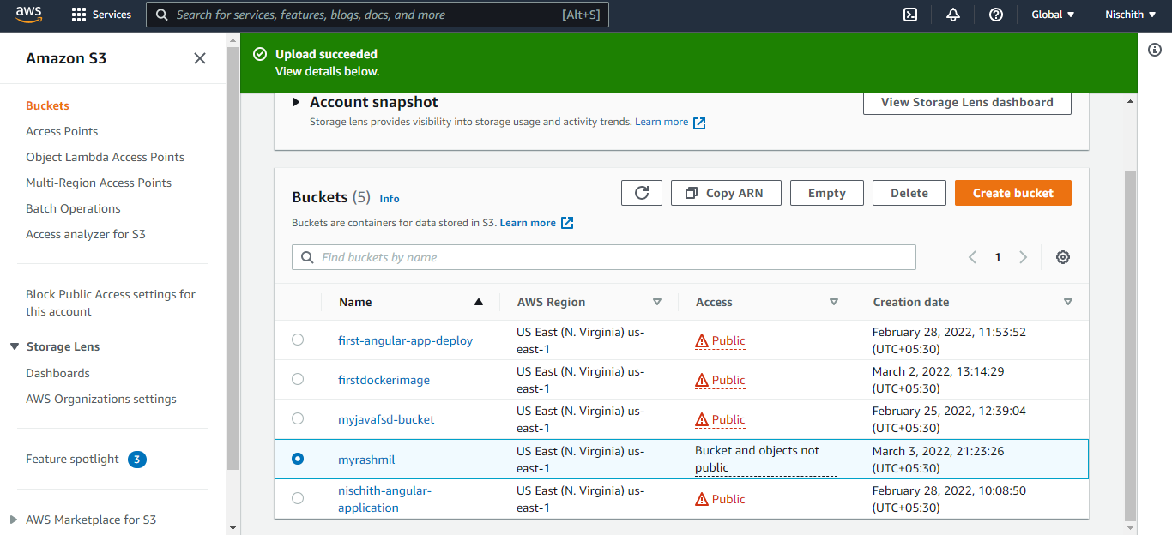

**Step 2:** Emptying the bucket

* Verify the content present in the bucket

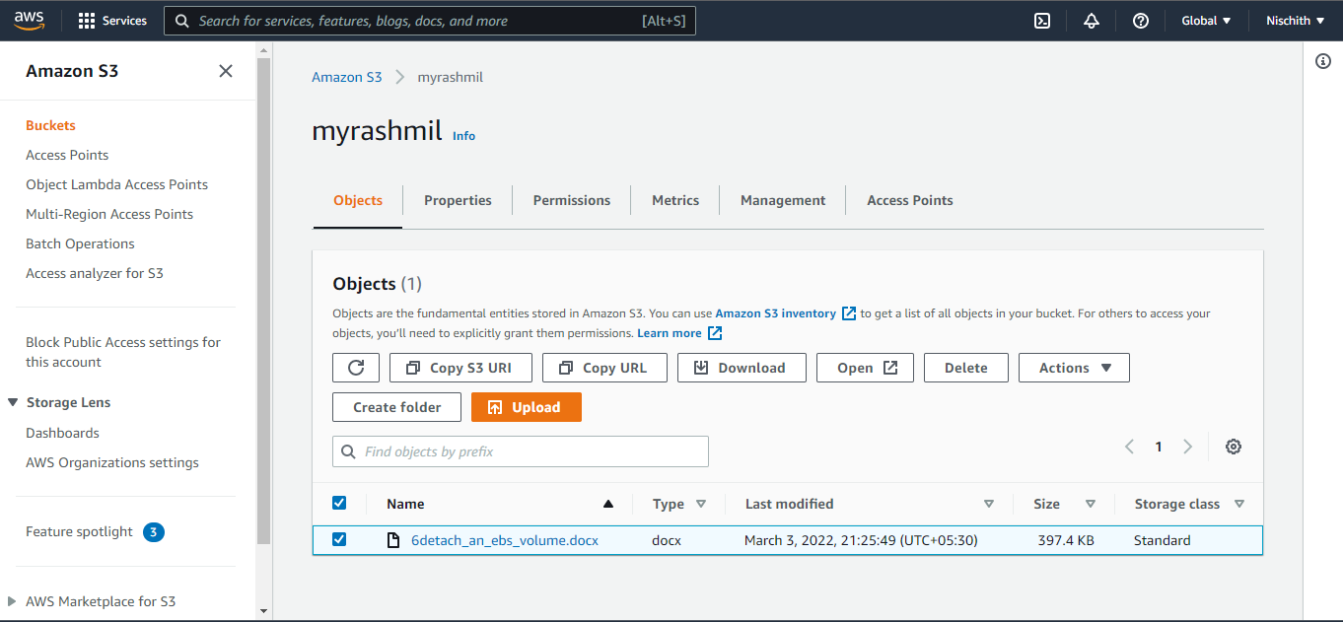

* Empty the bucket by deleting the objects

